CONFIRMATION OF MONGODB INSTALLATION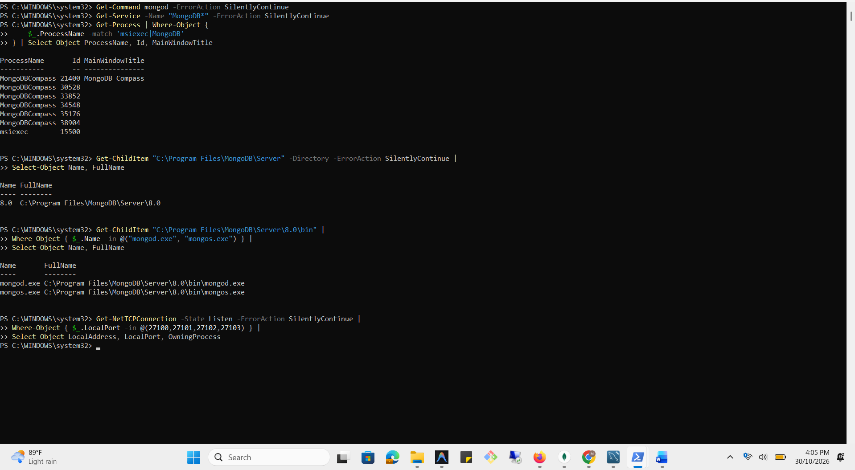

CREATION OF SHARDING DIRECTORIES
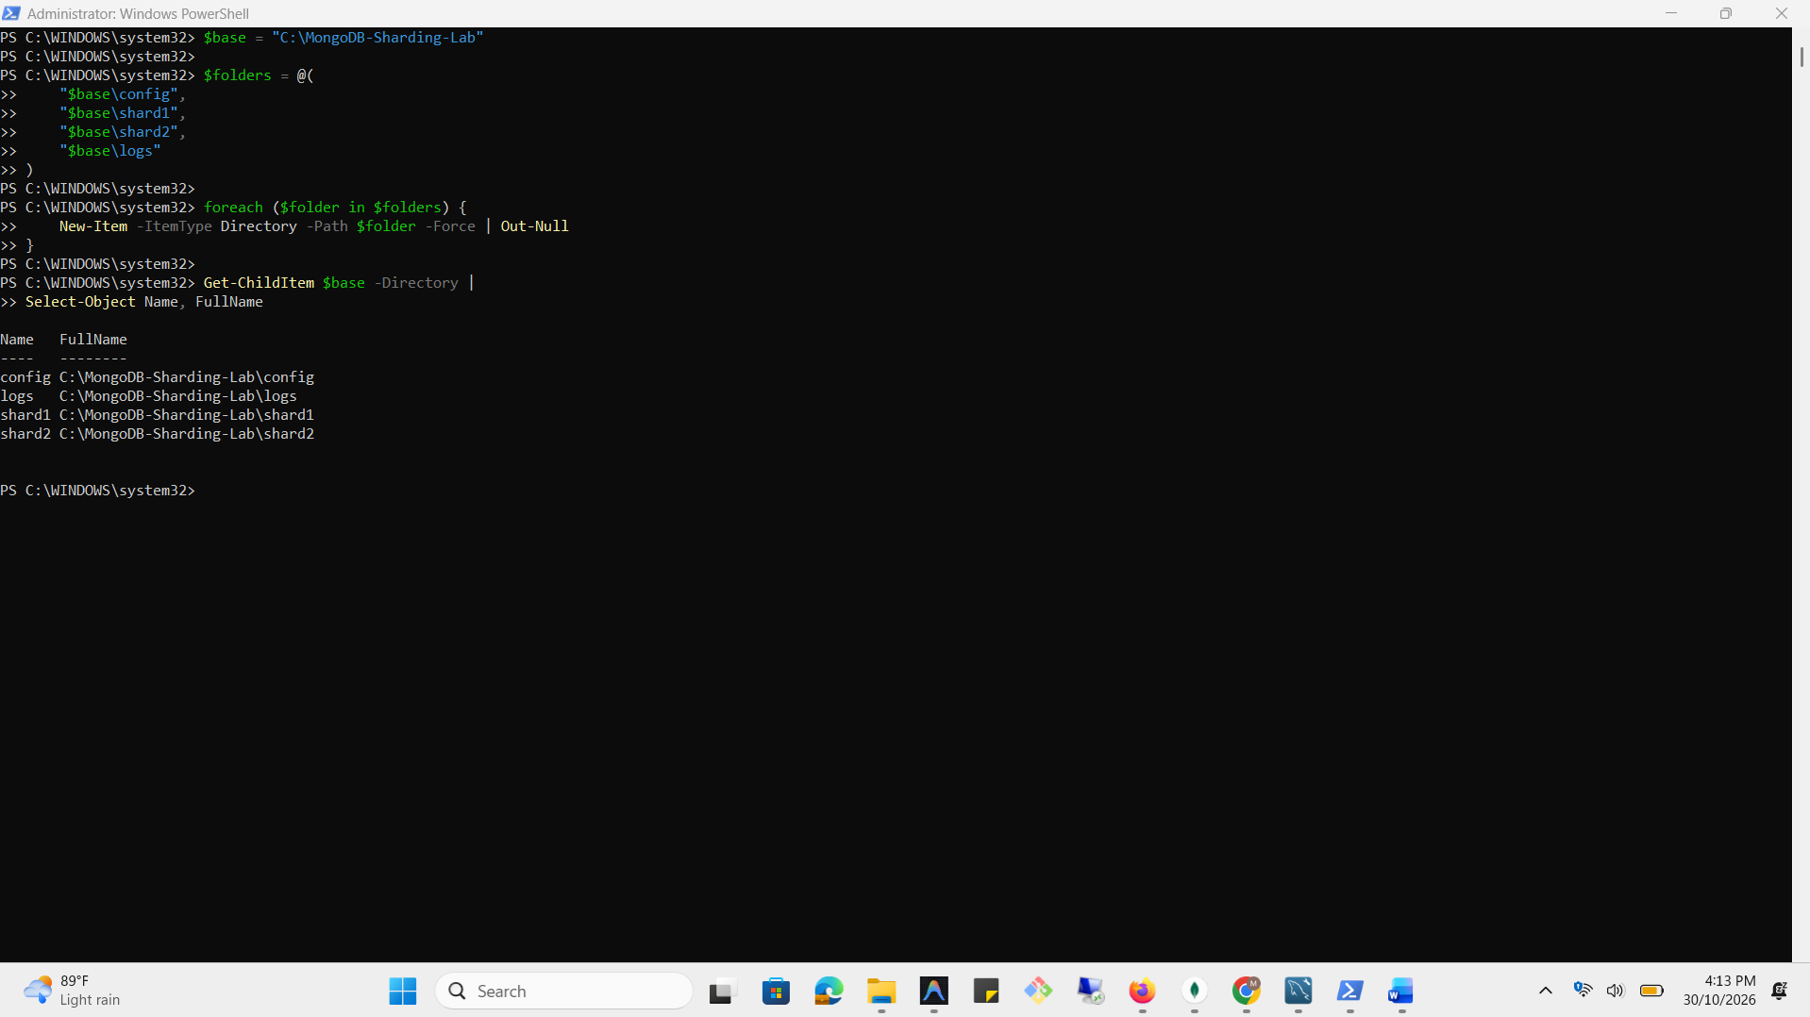

STARTING MONGODB SERVER
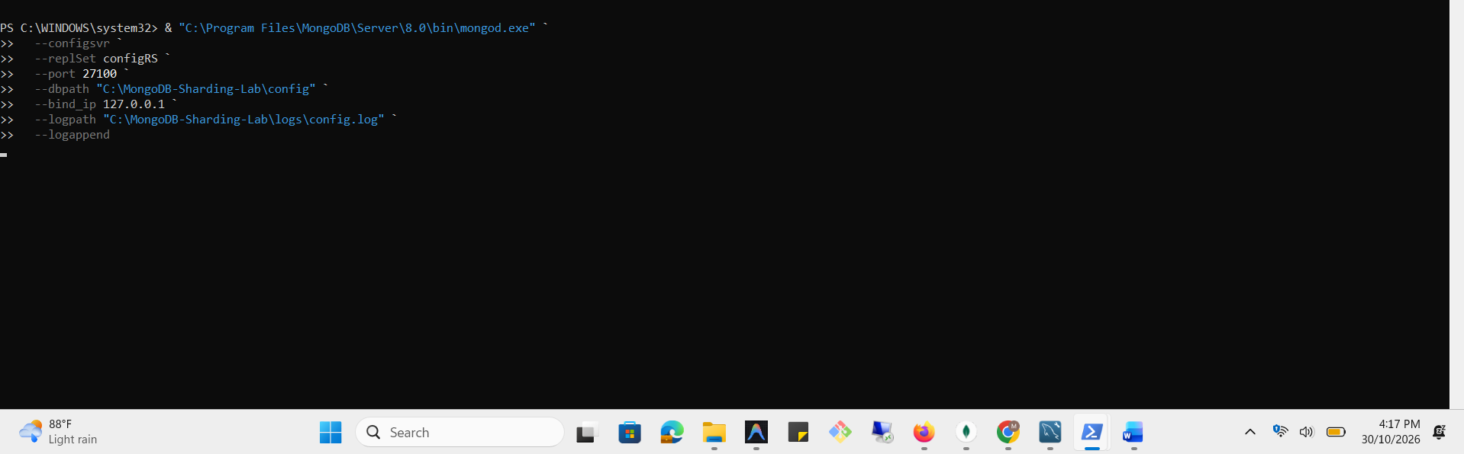

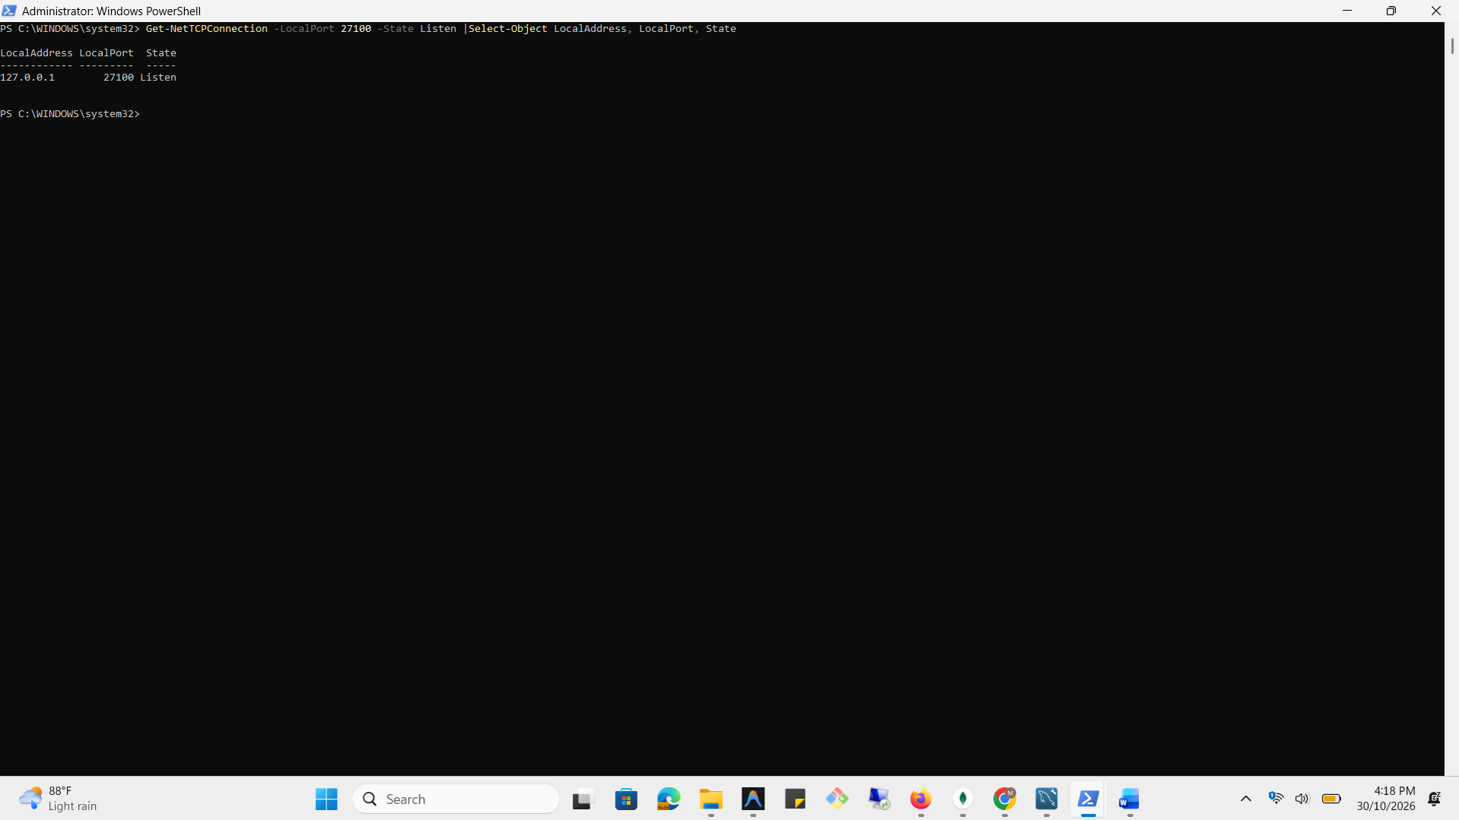

INITIALIZE THE CONFIGURATION SERVER REPLICA SET
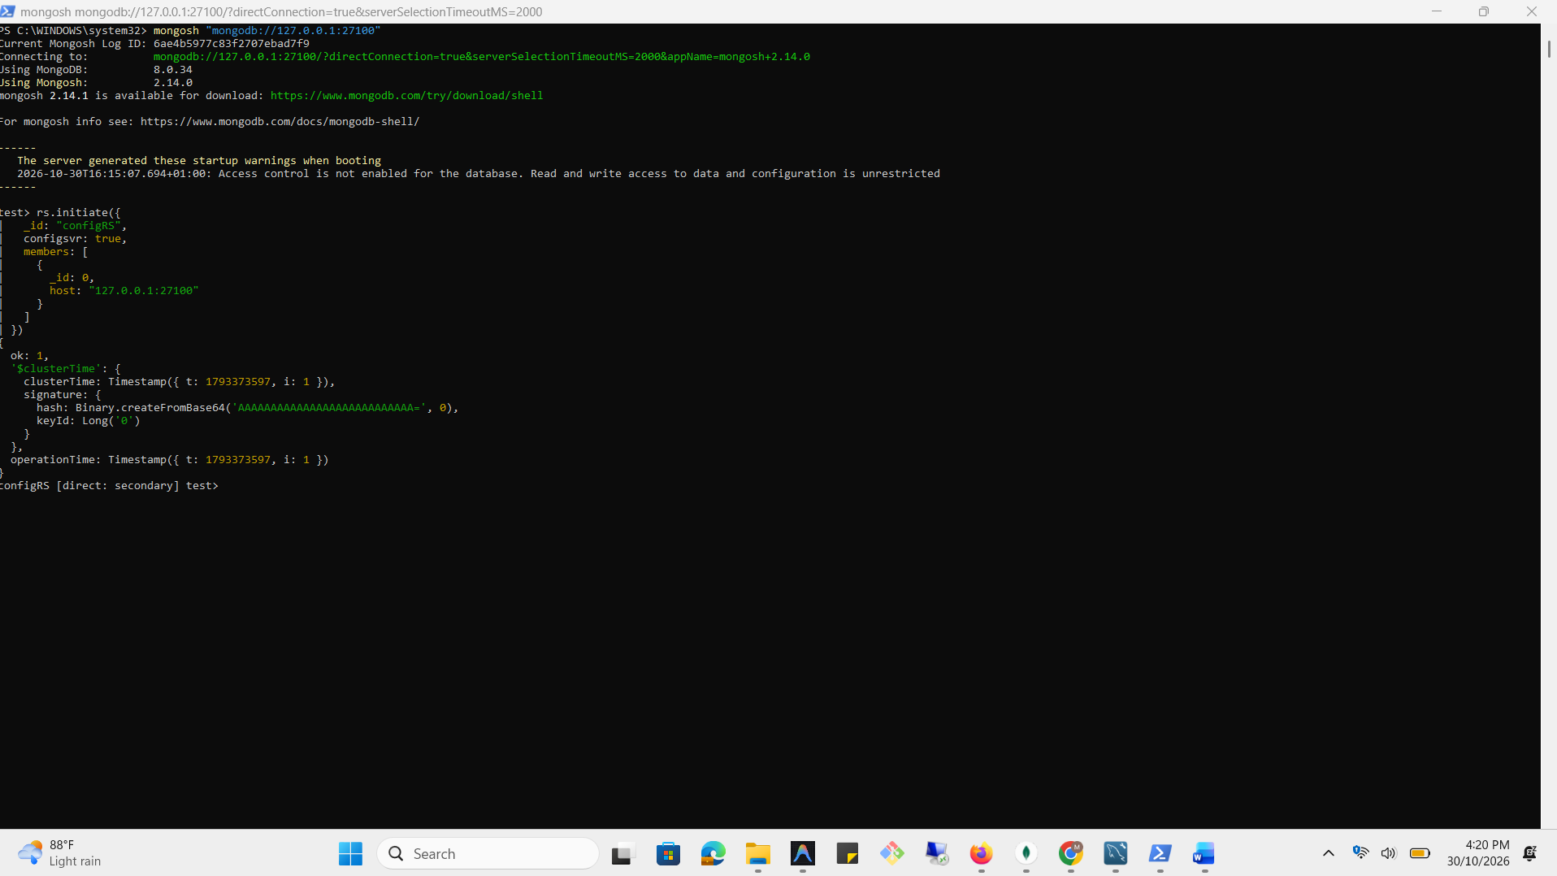

VERIFY REPLICAT STATUS
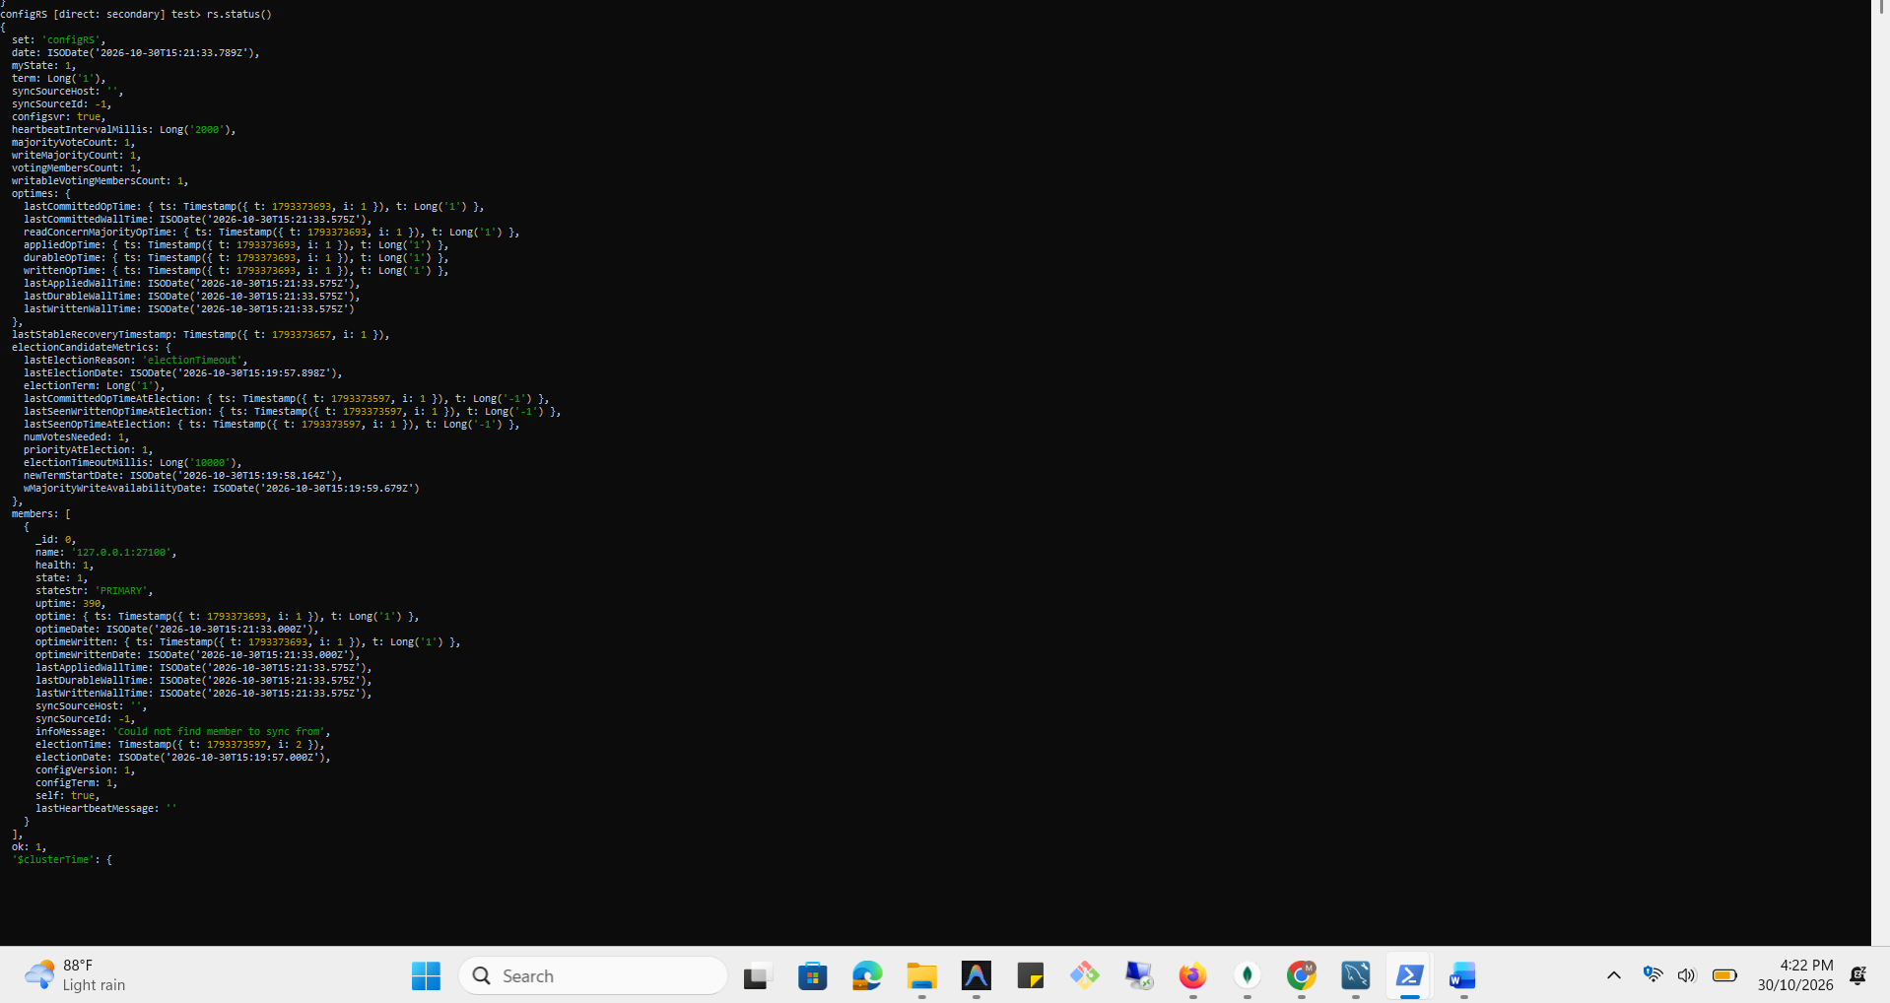
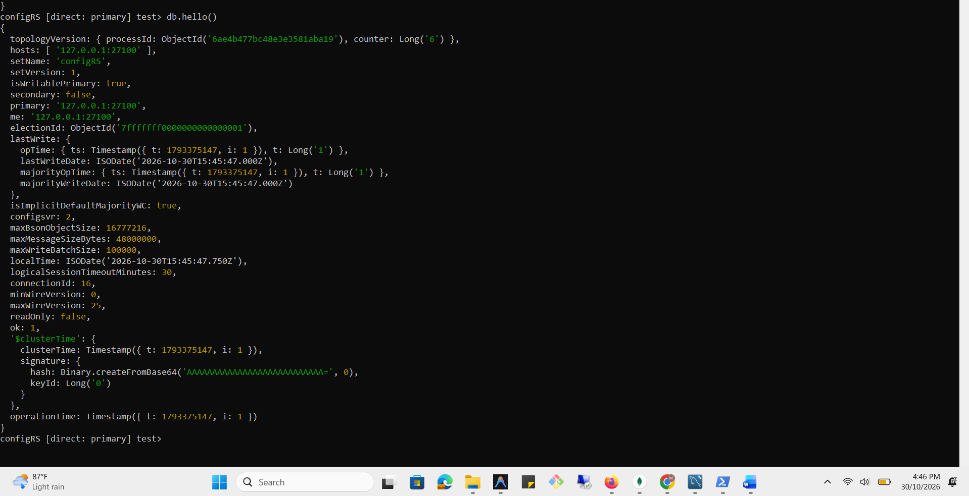

START MONGODB SHARD 1
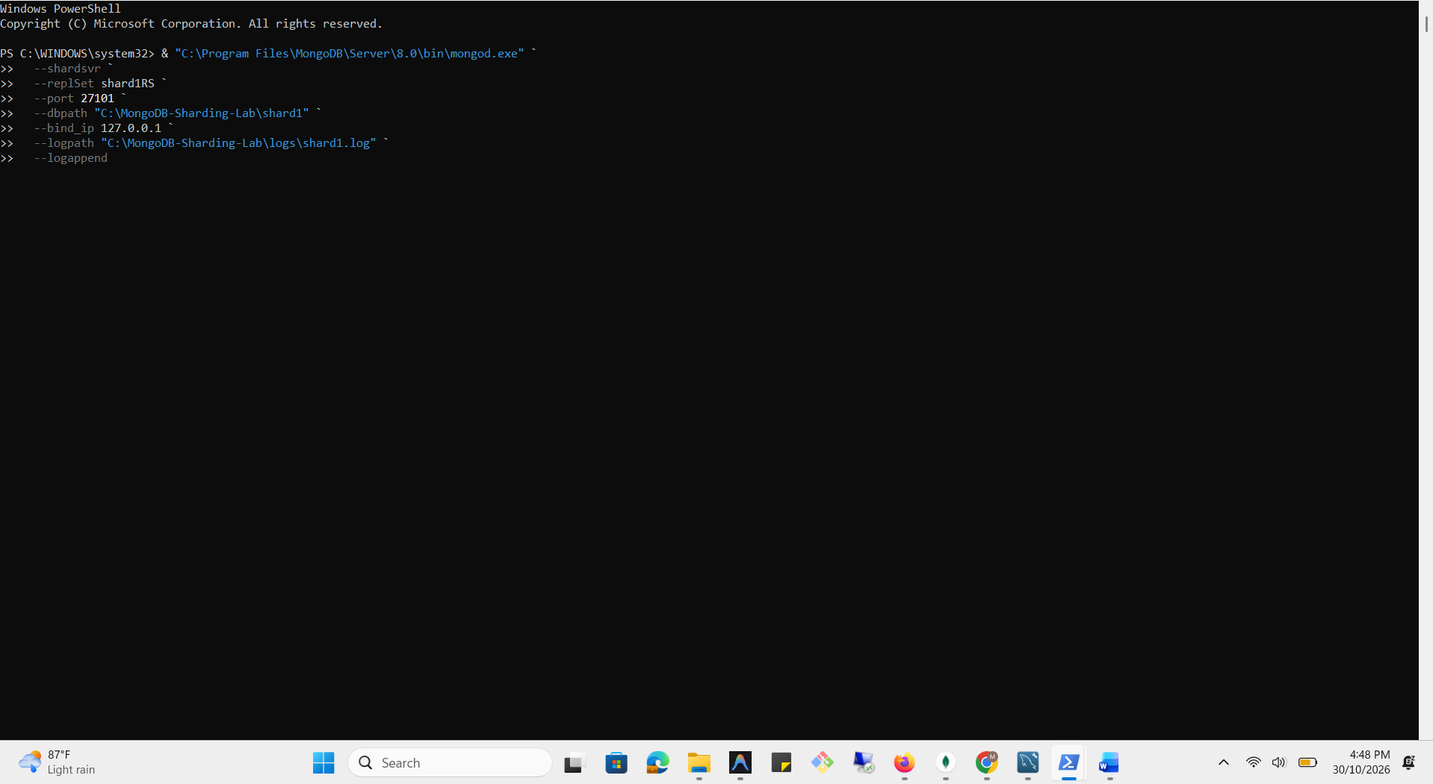
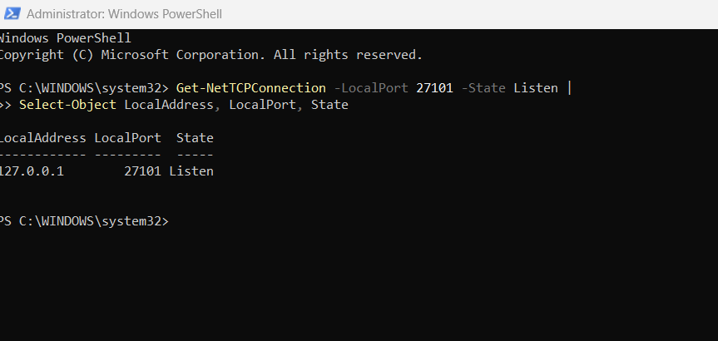

INITIALIZE SHARD 1 REPLICA SET
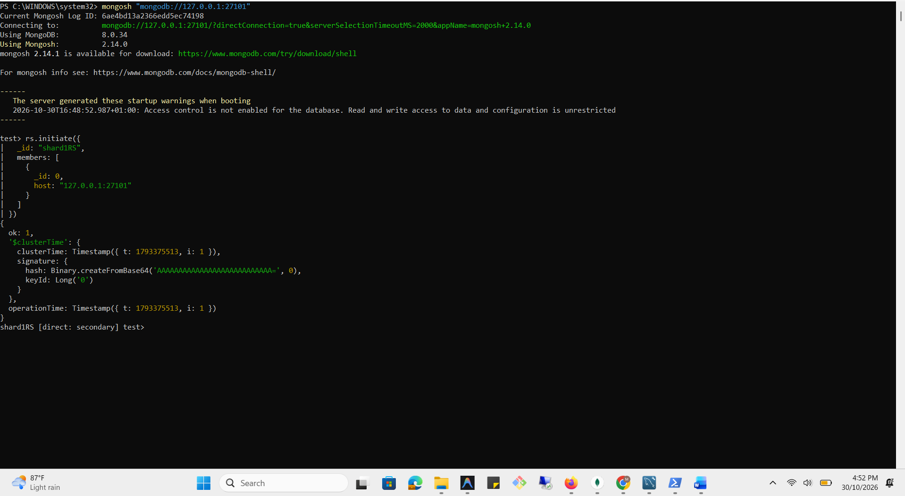

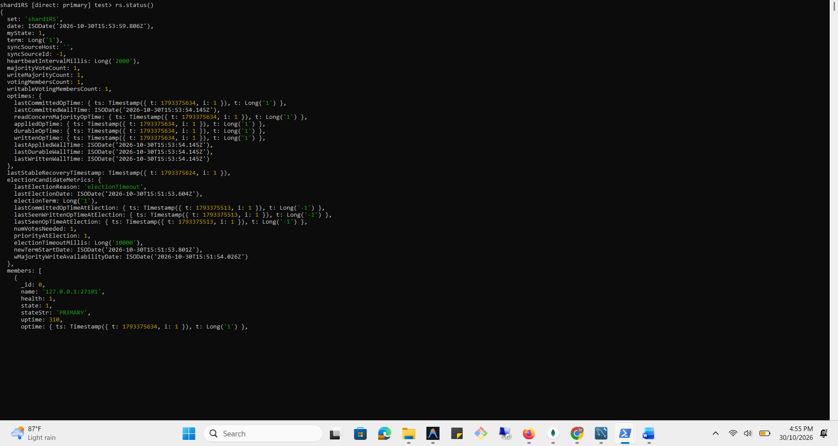
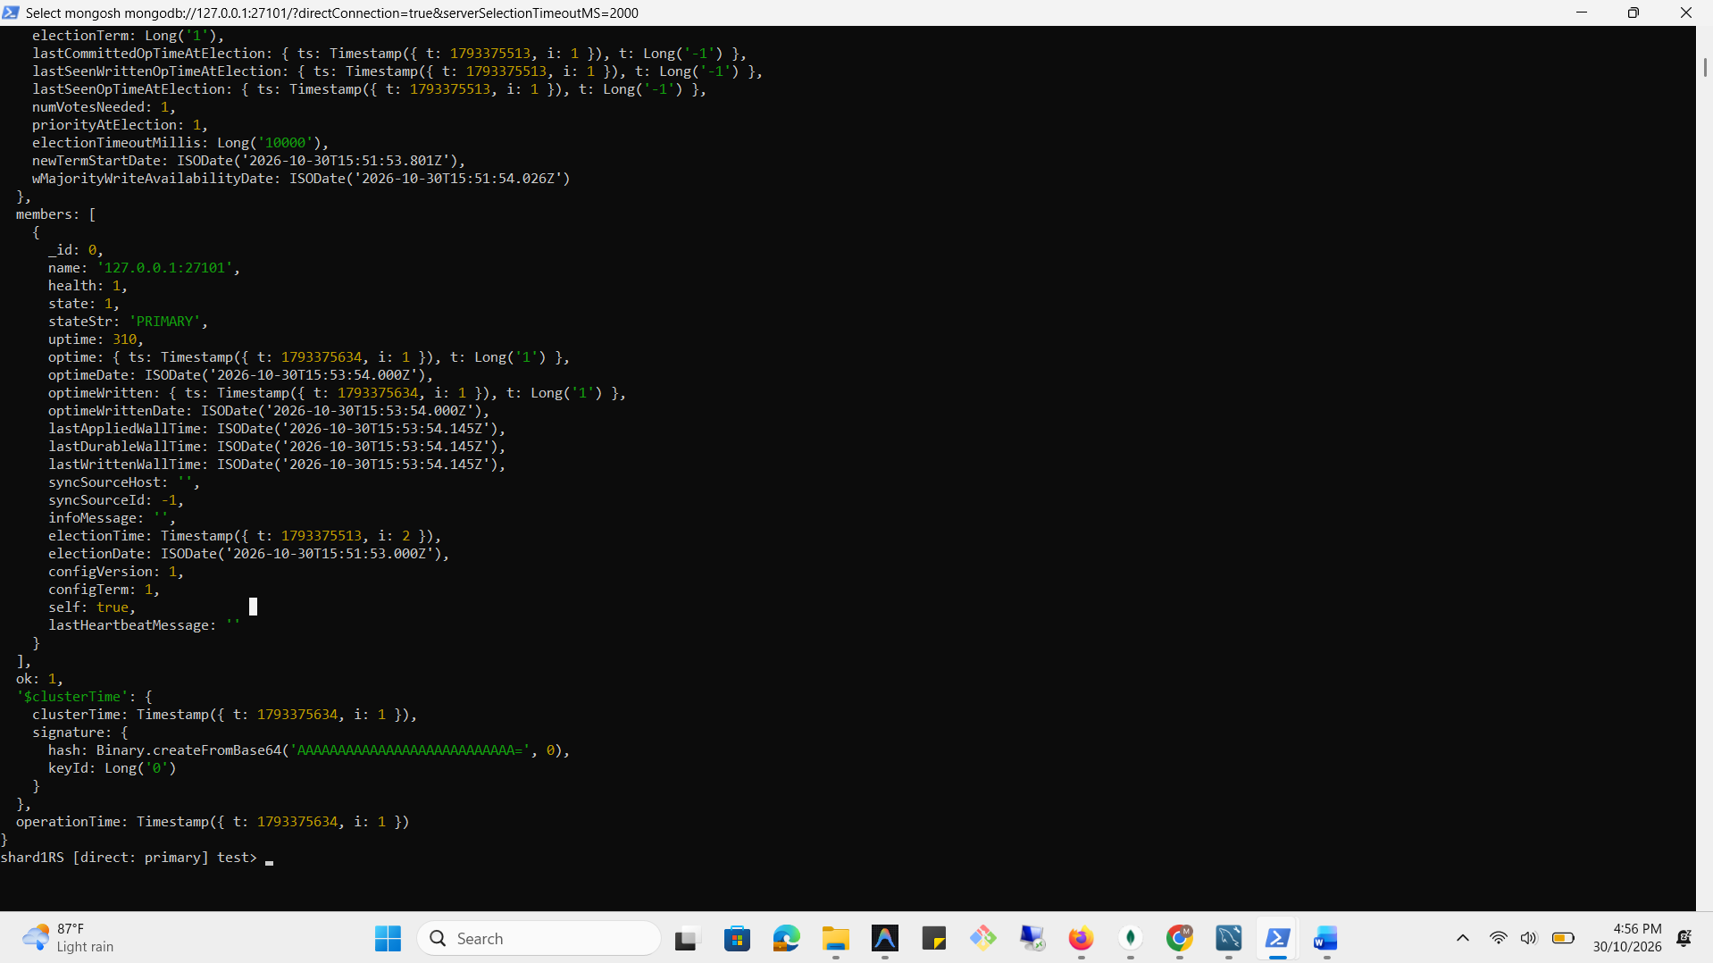

START MONGODB SHARD 2
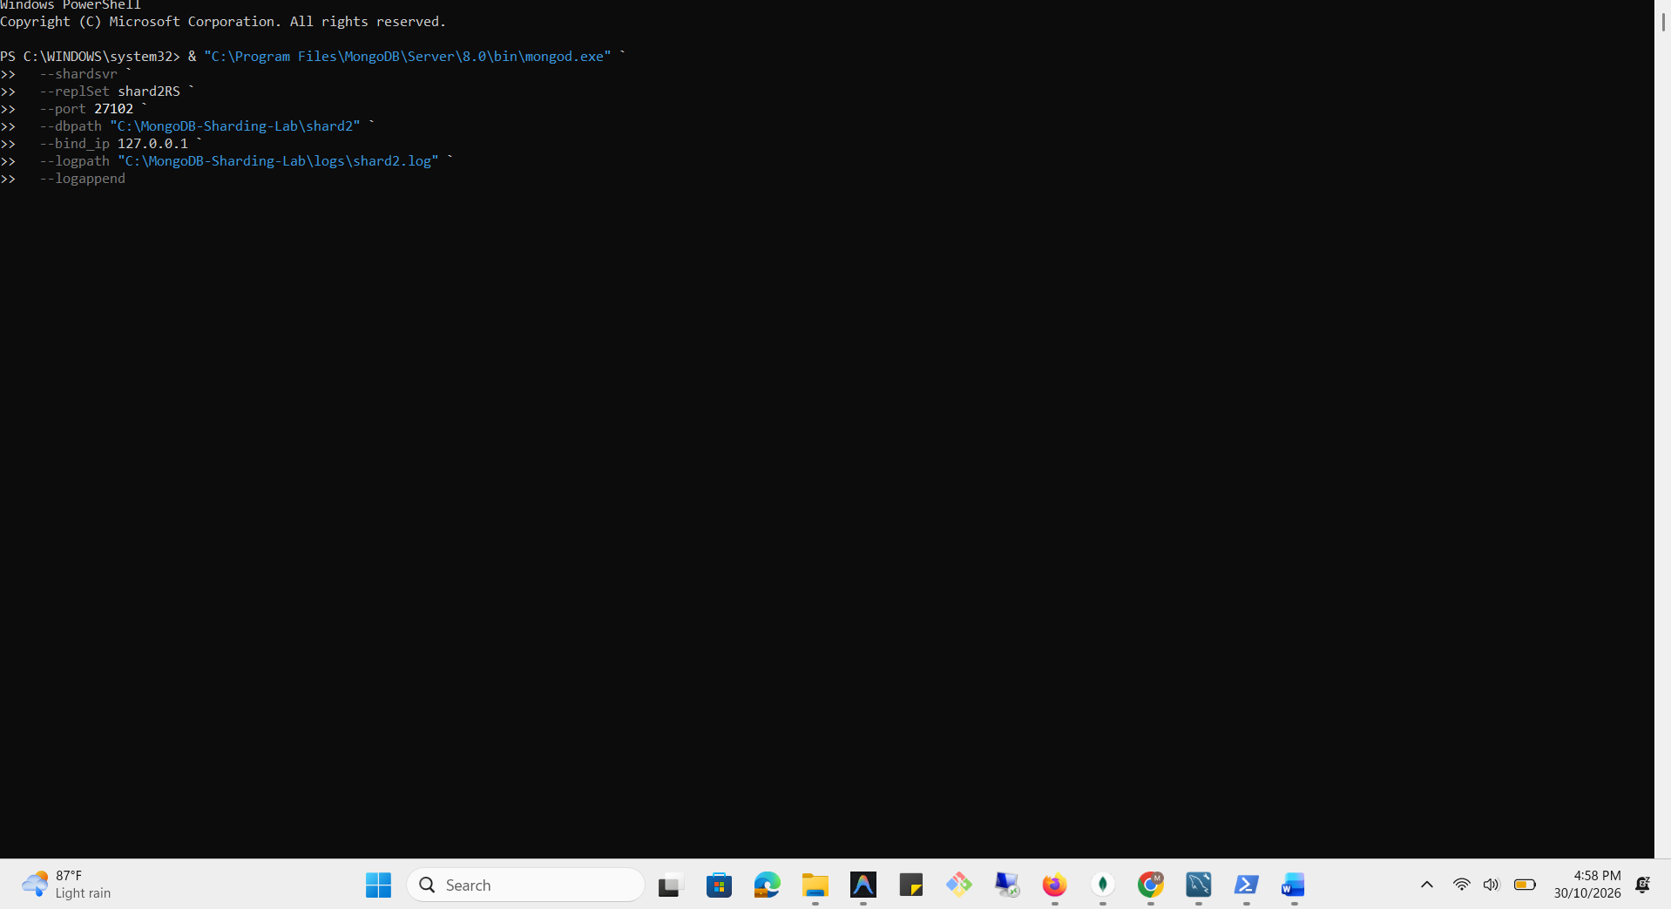

INITIALIZE SHARD 2 REPLICA SET
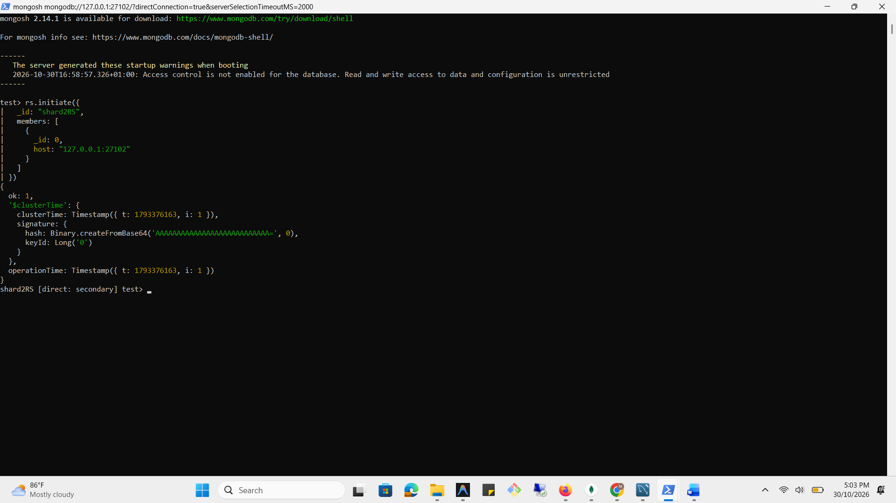

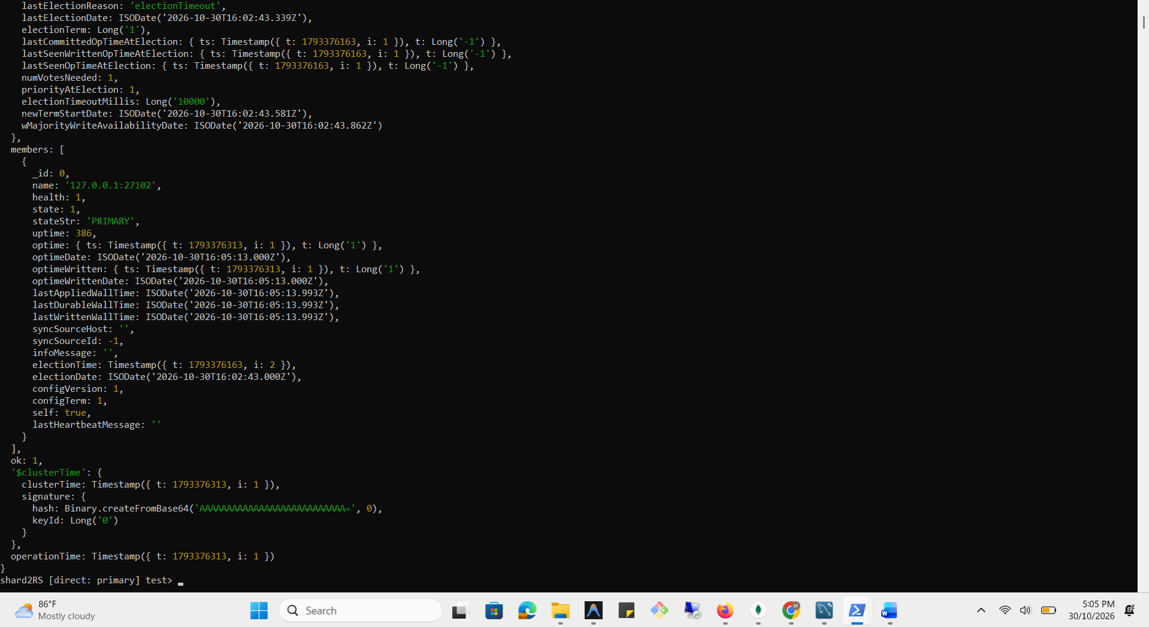

START THE MONGODB SHARDING ROUTER (MONGOS)
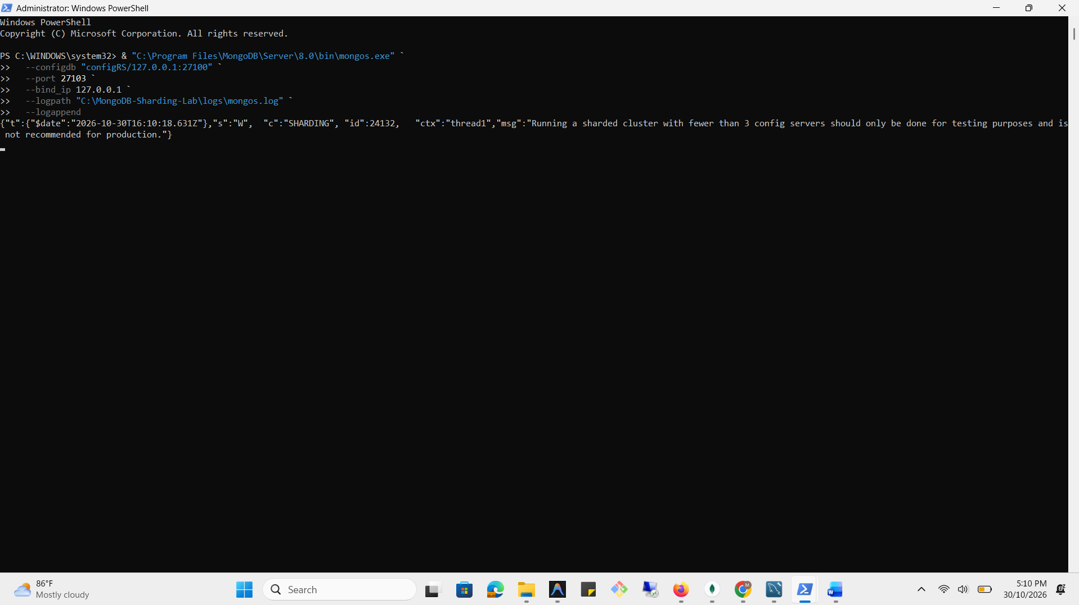
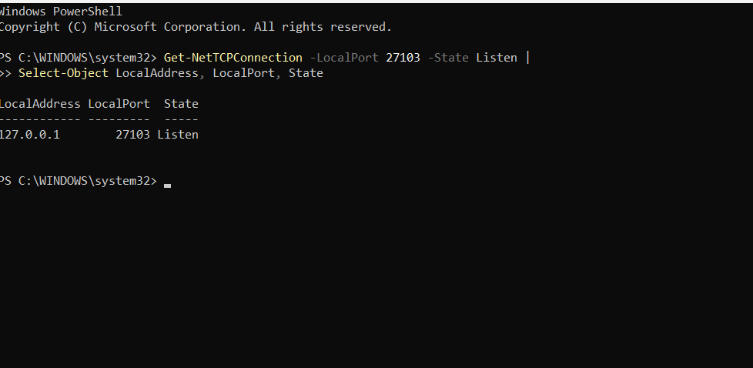

REGISTERING BOTH SHARDS WITH THE MONGODB ROUTER
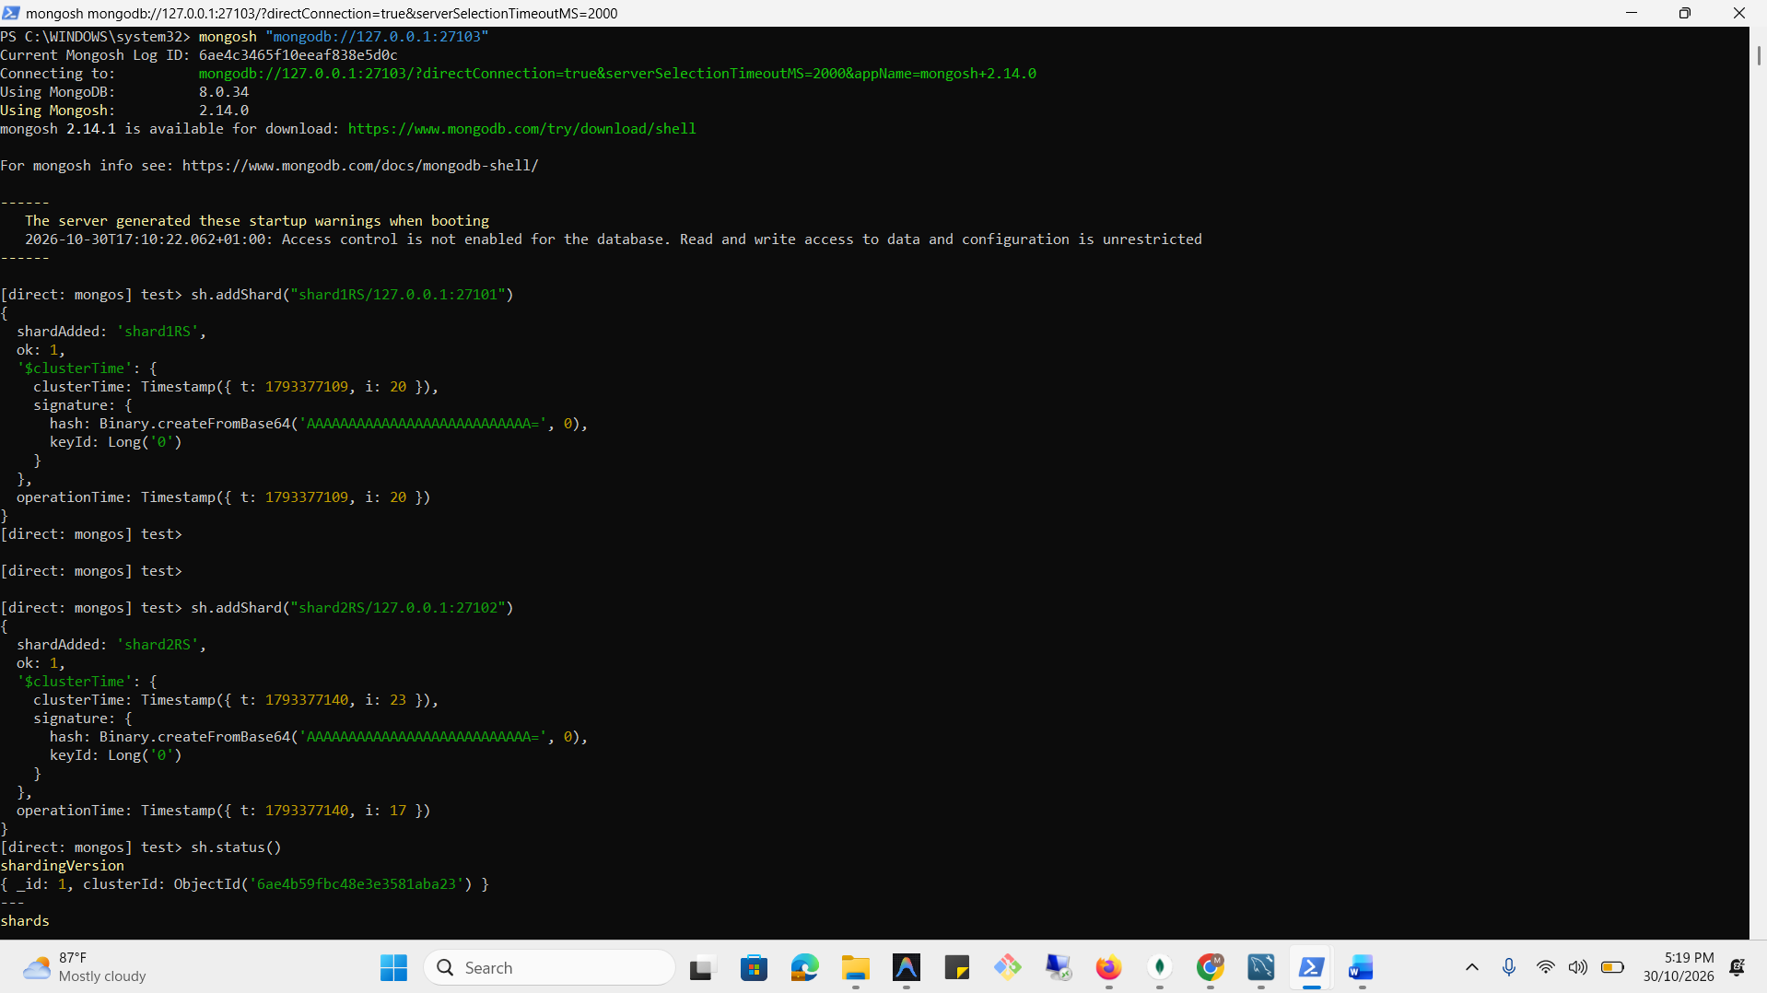

CREATE A DEDICATED BLITZFINTECH SHARDING DATABASE
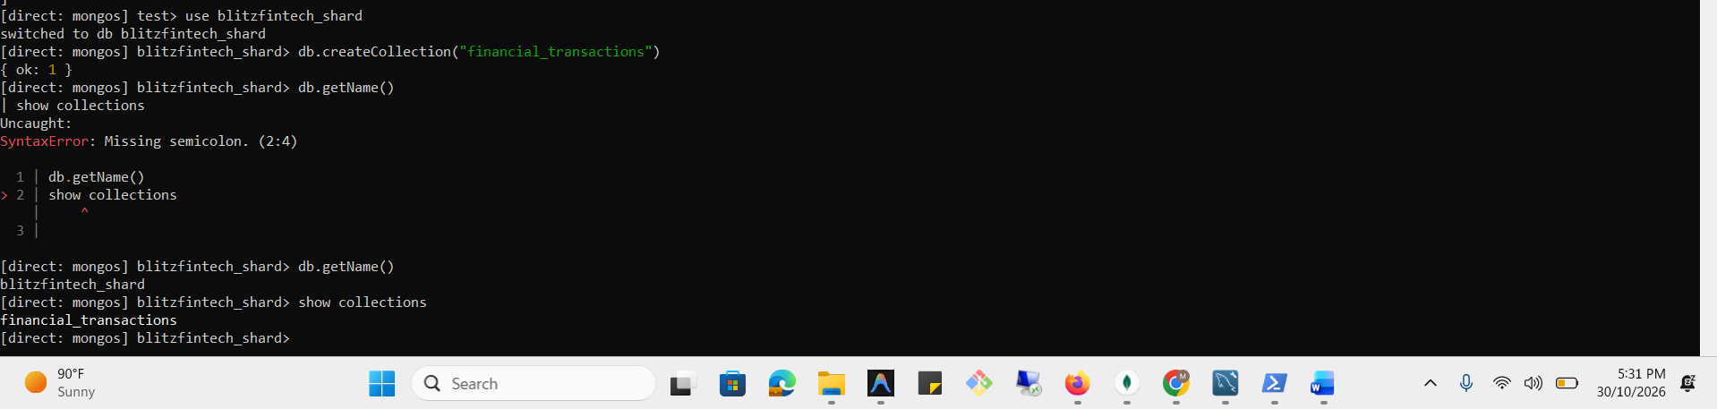
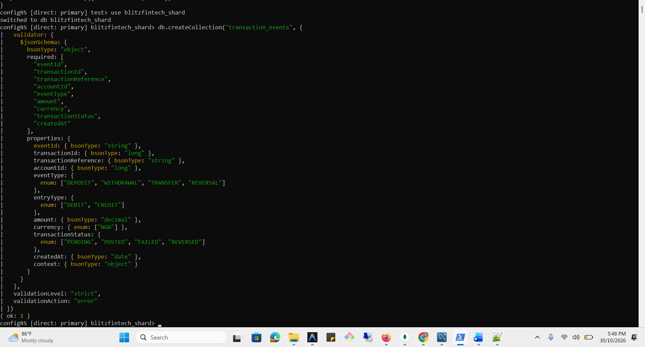

CREATE COLLECTIONS ON THE ROUTER
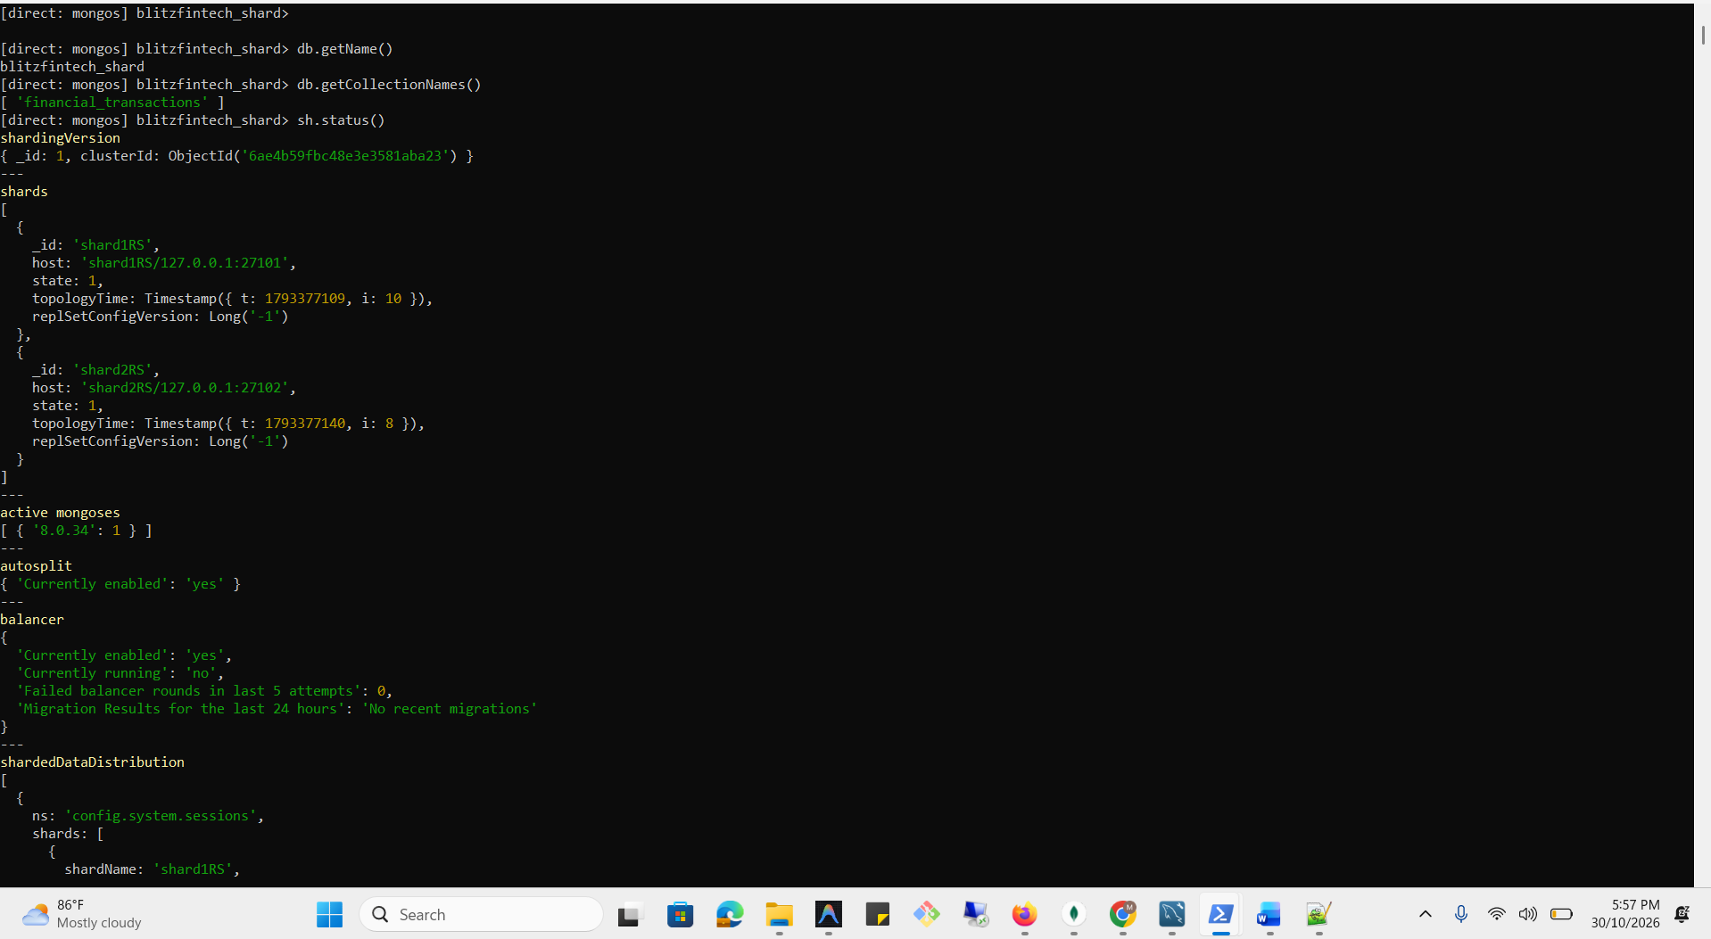
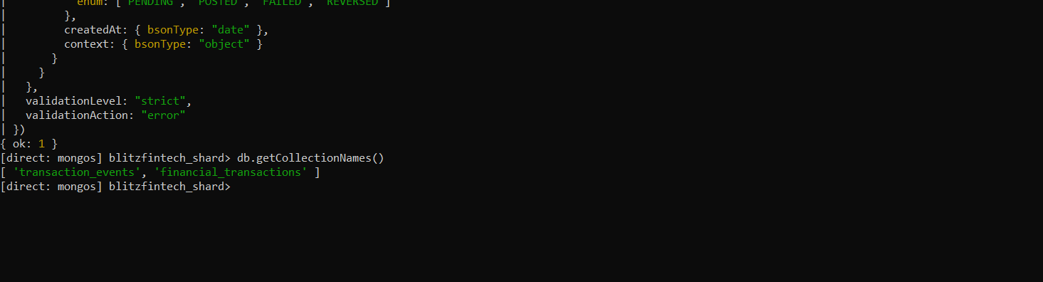

CREATE THE HASHED SHARD-KEY INDEX
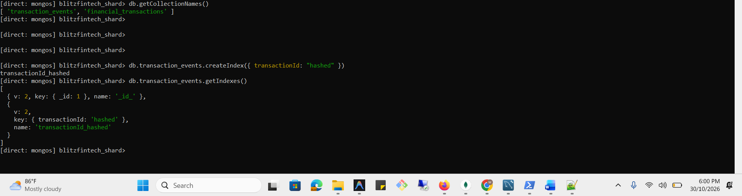

ENABLE SHARDING
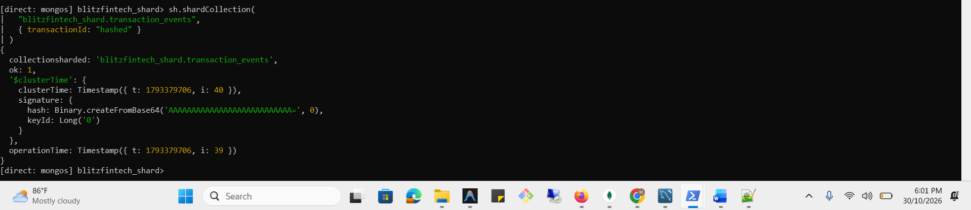

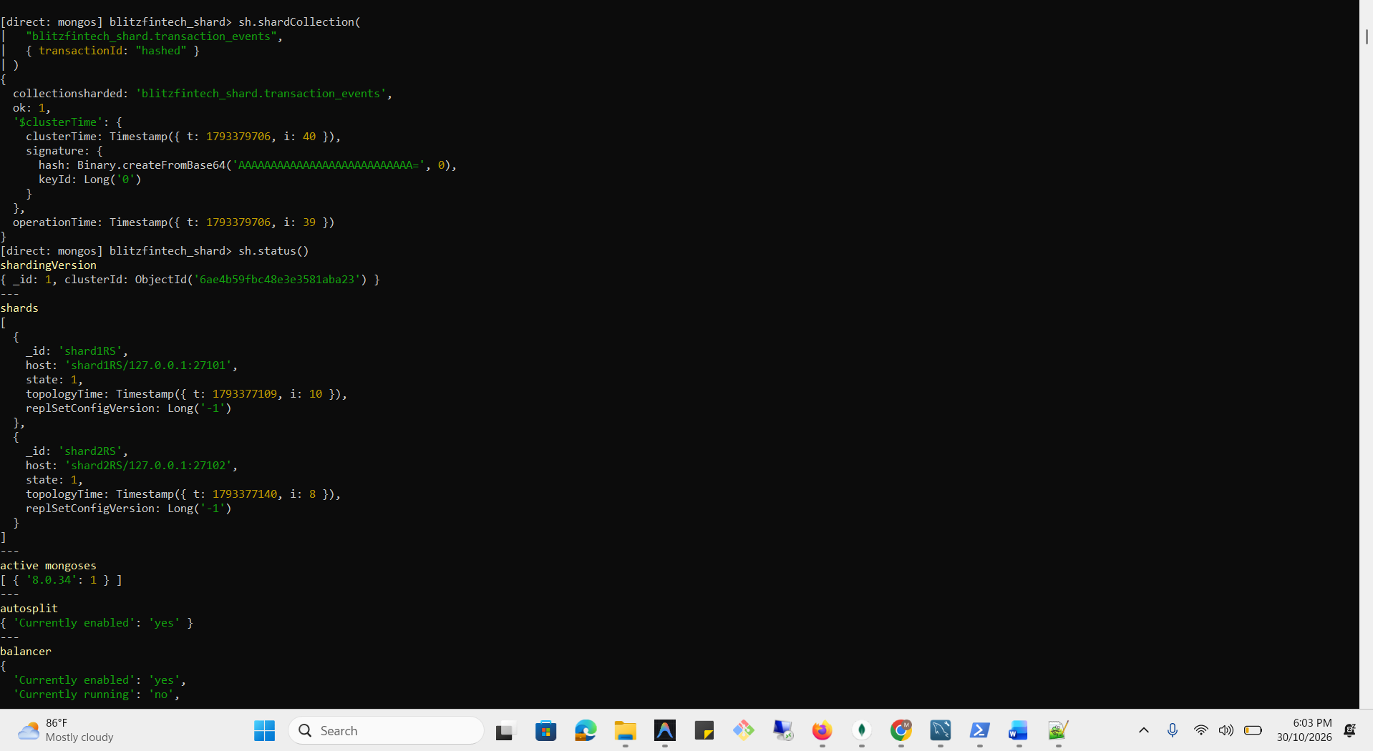

INSERT SYNTHETIC BLITZFINTECH TRANSACTION EVENTS
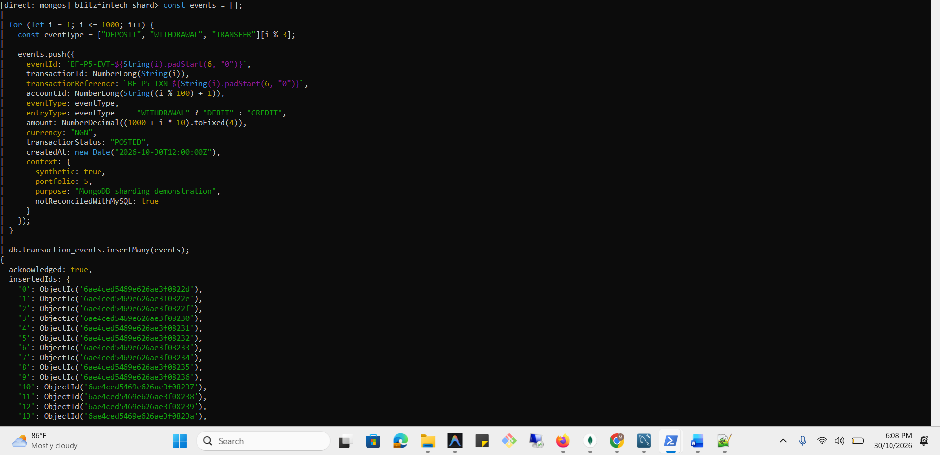

VALIDATION OF SHARDING
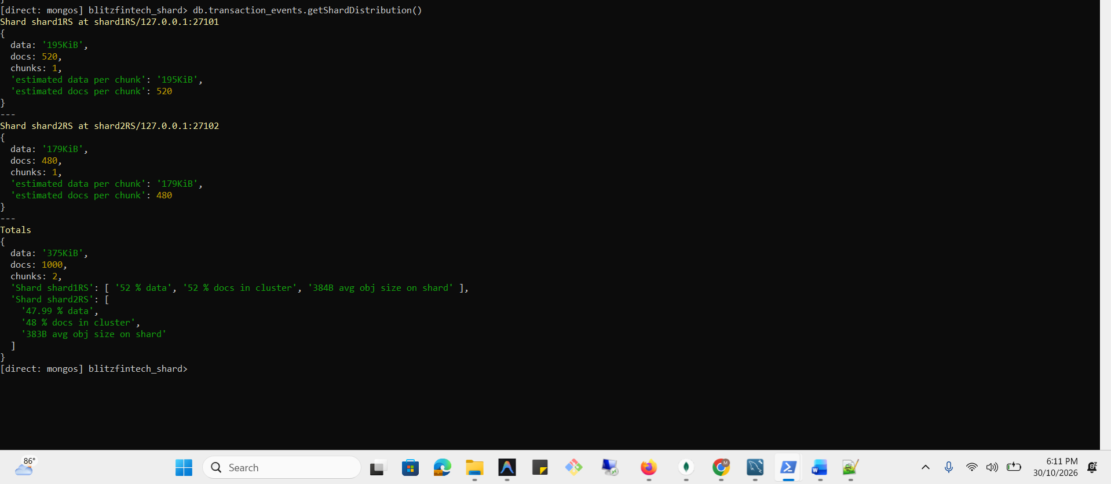

VERIFY SHARD-AWARE QUERY ROUTING
Query using the shard key
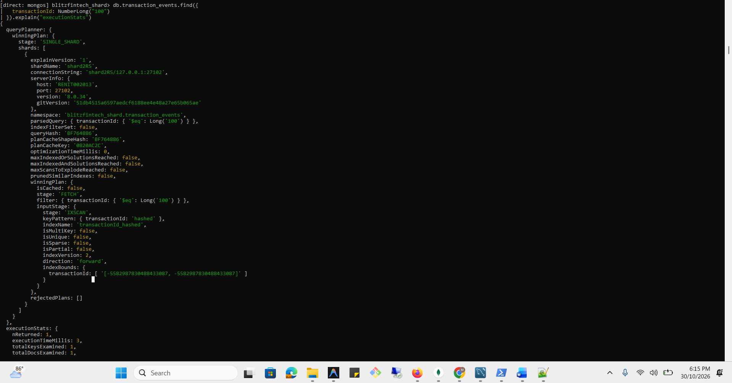
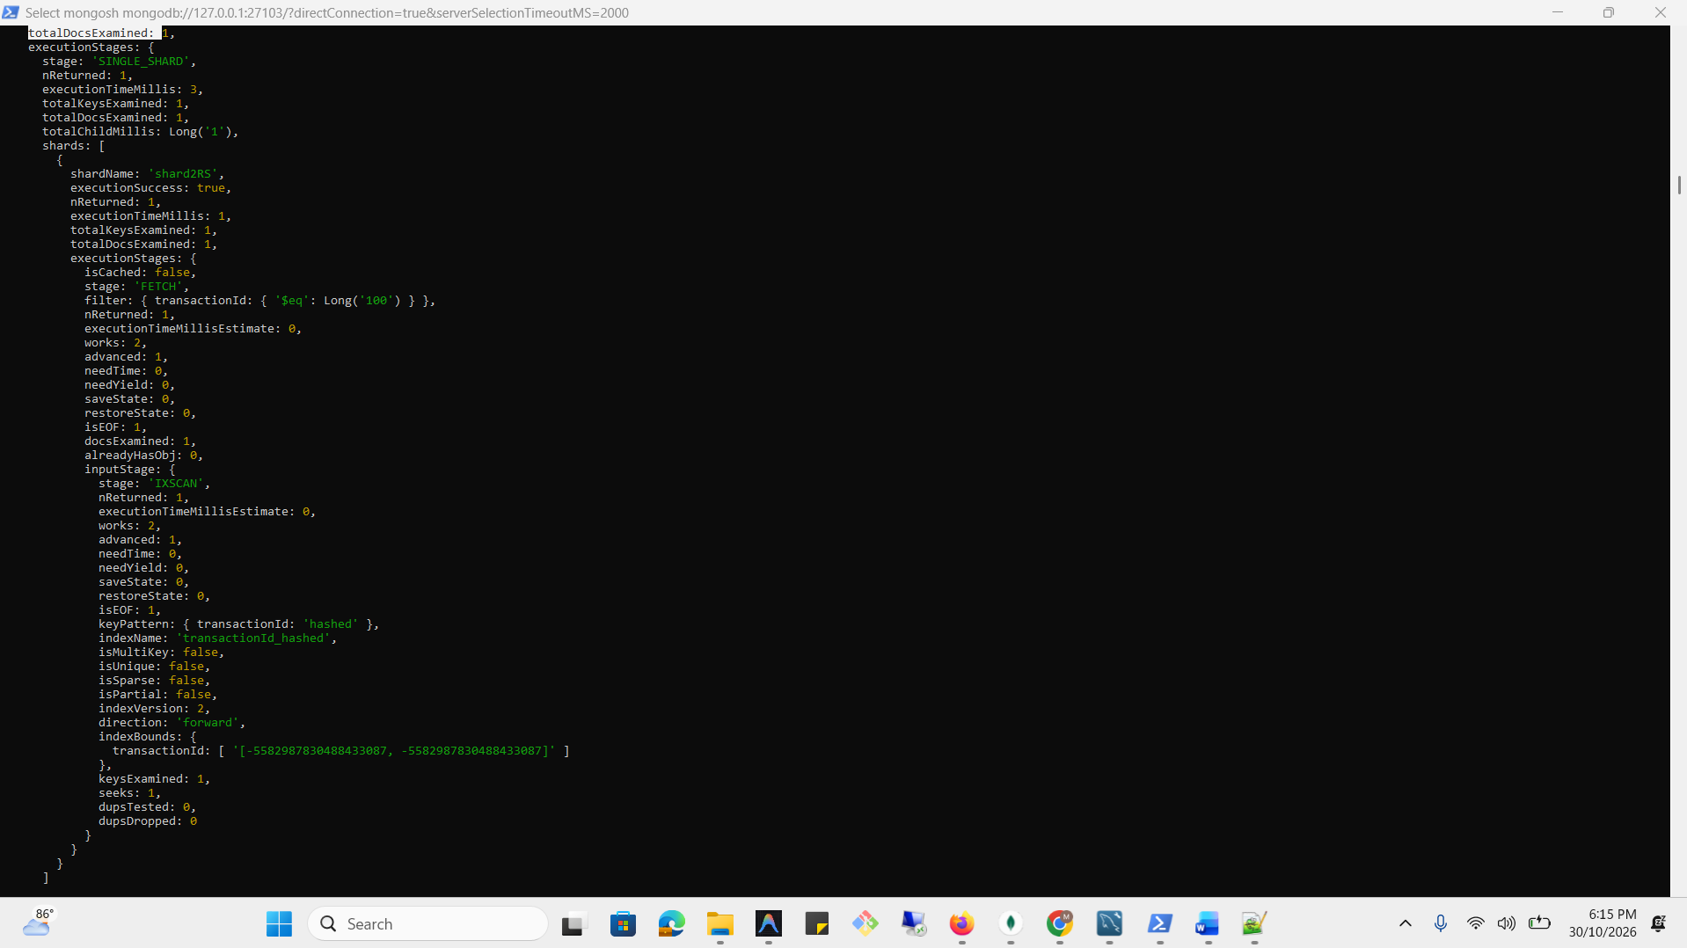
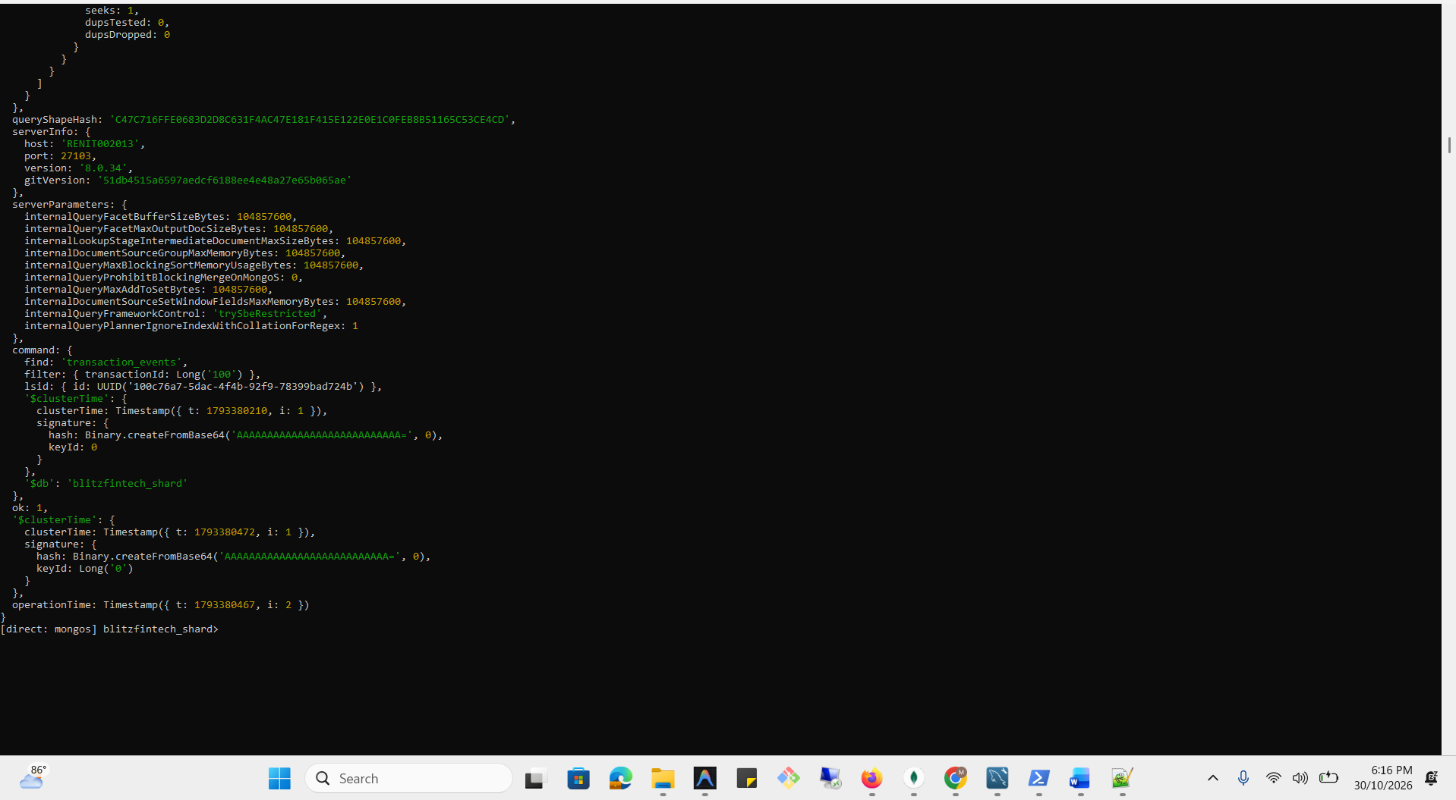

Query without the shard key


